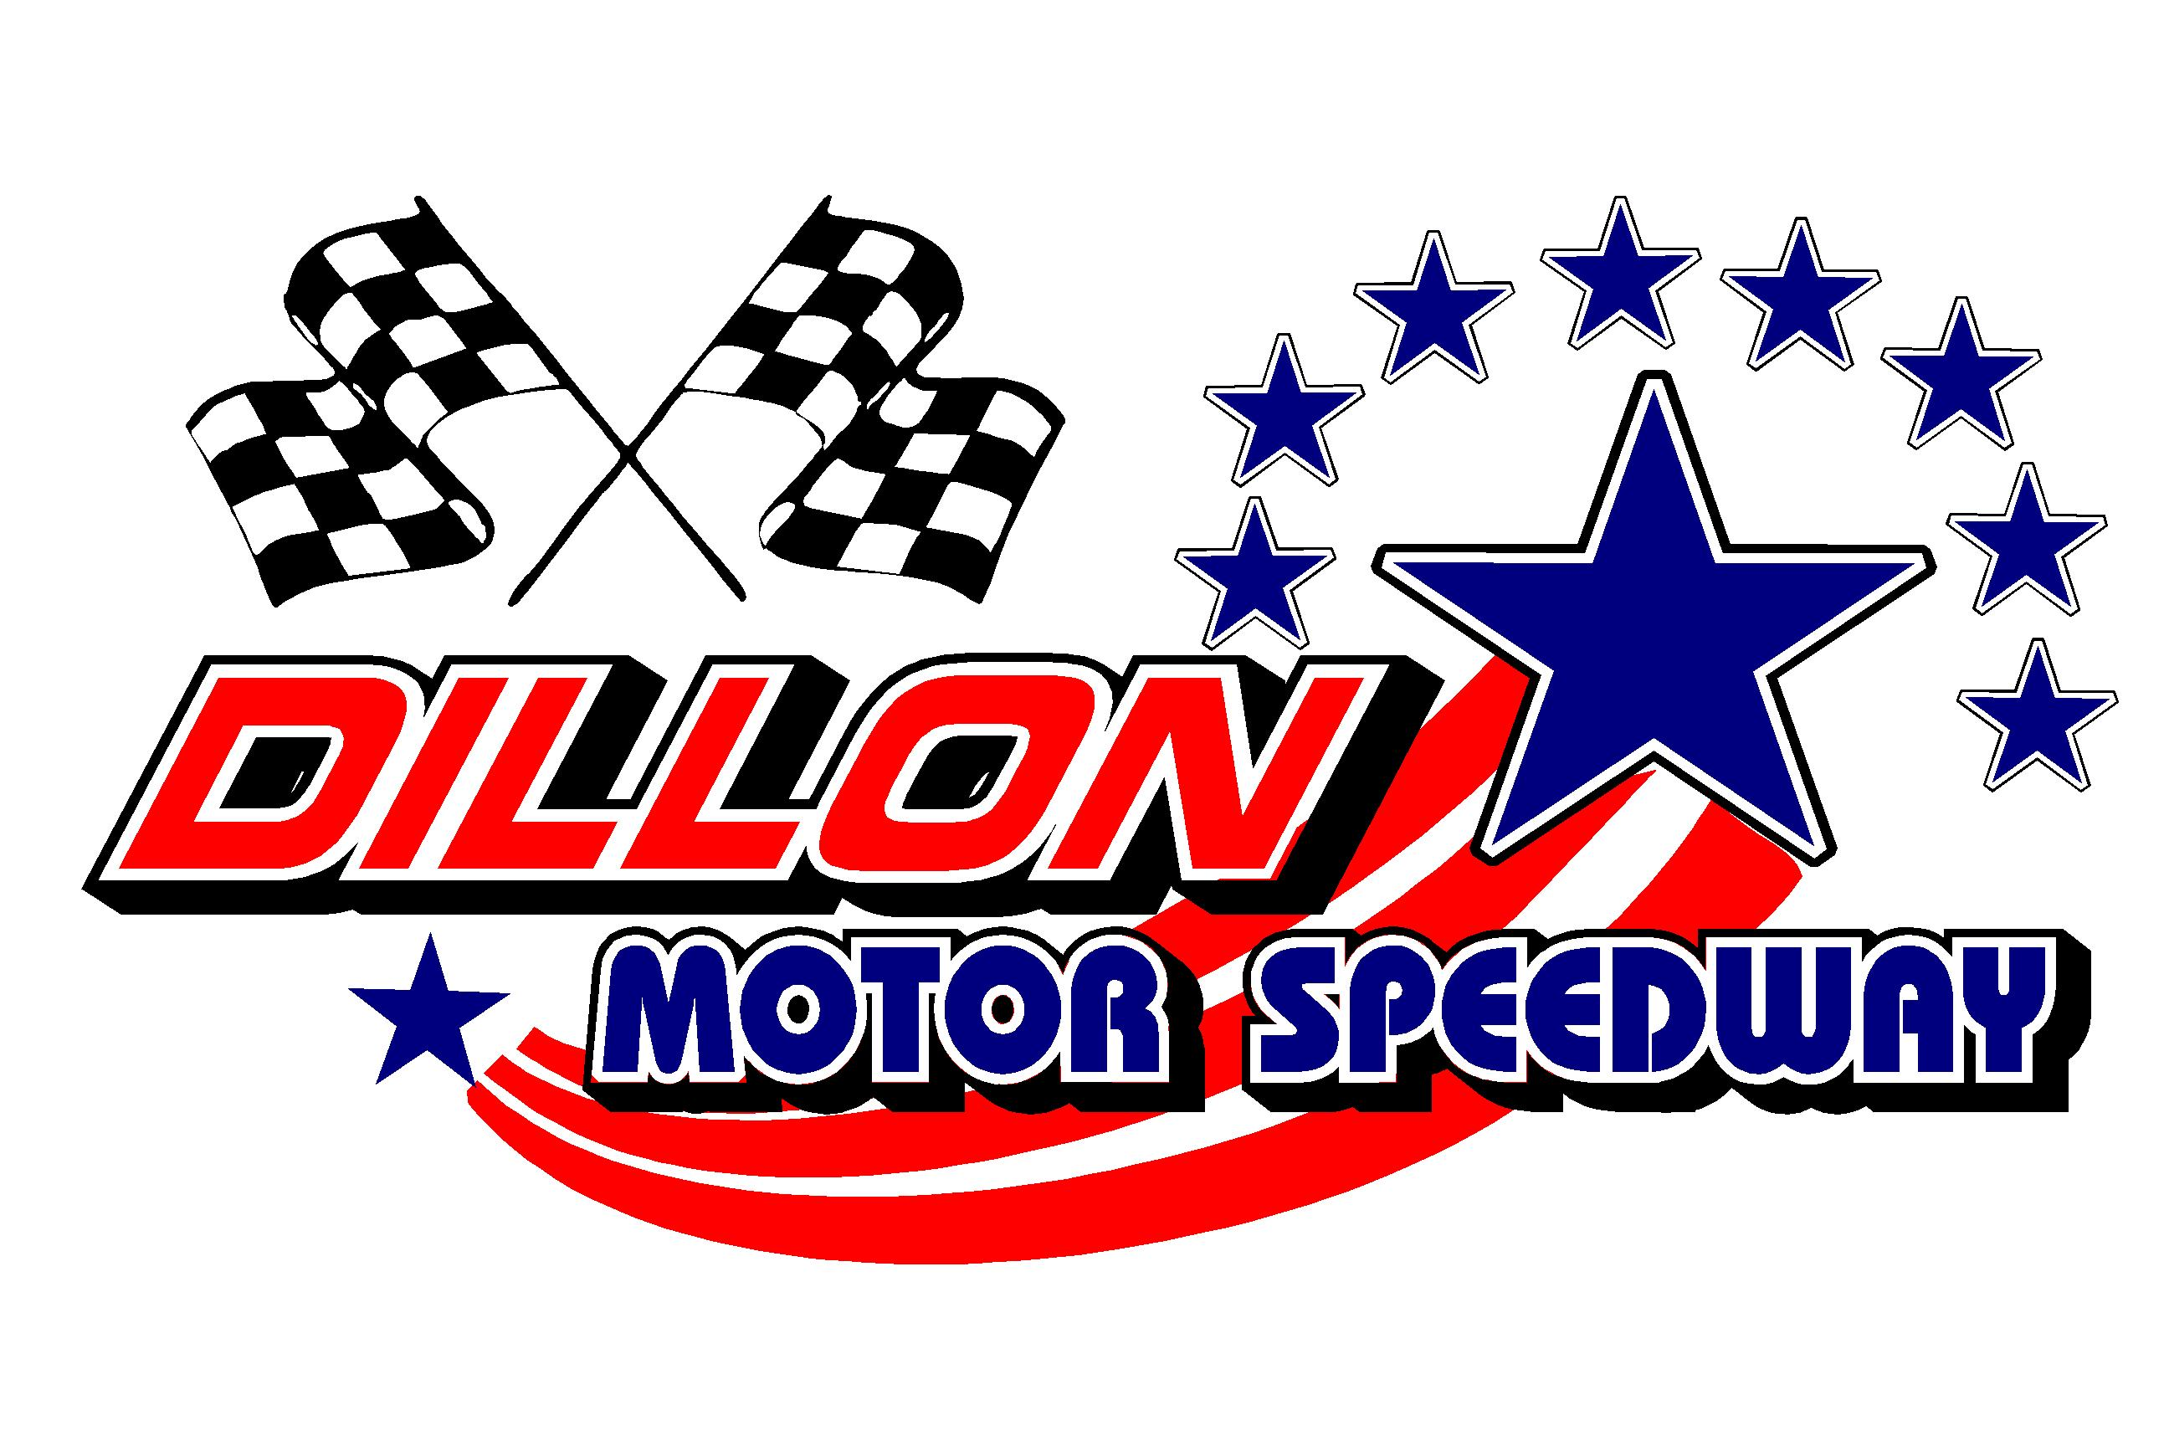

New Years MAV TV BASH January 8-10, 2021
Drivers Pre Enter For Special Provisional Starting Positions
Speedway Needs This Form Filled Out Early For The MAV TV Crew

Driver’s Name (print) ______________________________________Date_________________

Street __________________________________ City ______________________ State _______

Cell Phone_______________________ Email_________________________________________

Facebook_____________________________Twitter:__________________________________

Home Track__________________________2020 Wins___________________________________

Championships and Awards (Continue on Back)_______________________________________

______________________________________________________________________________

______________________________________________________________________________

Car Number (Up to 3 digits) 1st __________ Car Colors______________________Car Type______________

_____ Circle the Class you will Race In__________________________

$2500 To Win STREET STOCK ENTRY - $100 $600 To Win (CMSC) 4 Cylinder Entry - $50

$1000 To Win CHALLENGER AR Series- $50 _ $500 To Win UCAR / Pure Stock Entry -$40

$200 To Win BANGER 6 Cylinder Series – $20

BASH Class Rules Are Located At www.dillonmotorspeedway.com Under Rules Section
.
Make Sure You Send in Your Pre-Enter for this EVENT
No Money Required To Be Sent! Pay at Sign In Window the Day of the Race

Email Form: cneal@dillonmotorspeedway.com
or US Mail to: Dillon Motor Speedway P.O. Box 148 Dillon, SC 29536
Drivers Pre Enter For Special Provisional Starting Positions
11th Annual NEW Years BASH Saturday And Sunday Jan 8-10

