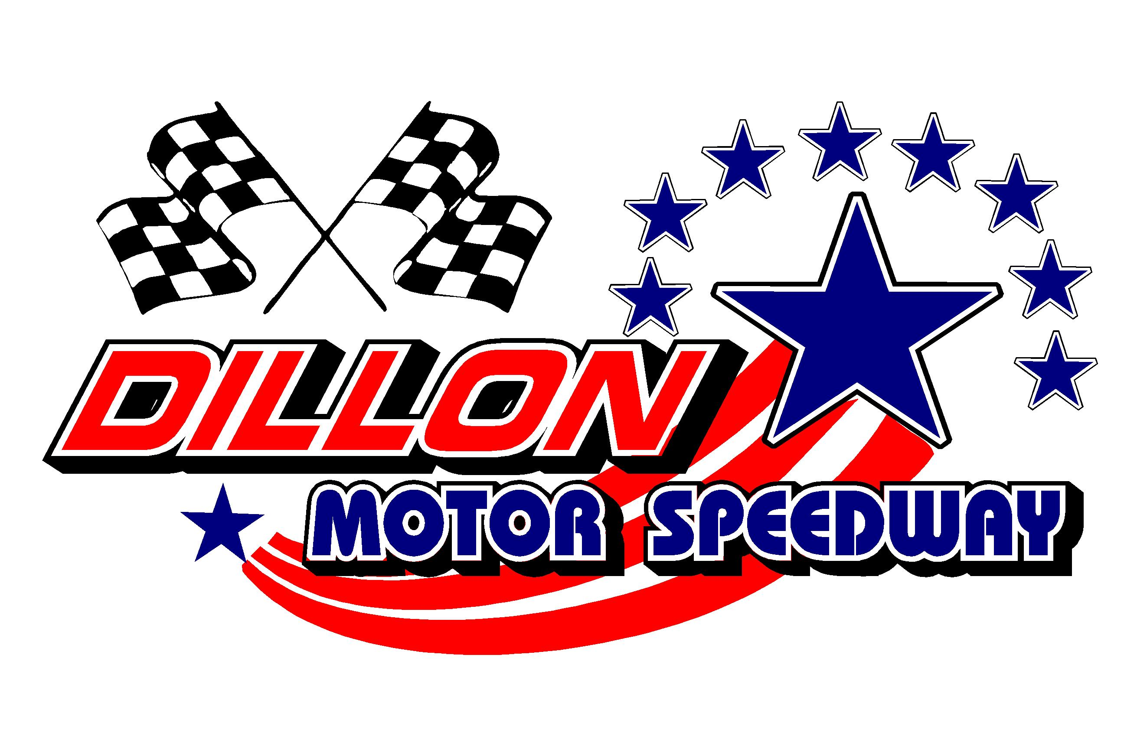

New Years BASH January 6-8, 2023
Drivers Pre Enter For Provisional Starting Positions & Bonus Money

Driver’s Name (print) ______________________________________Date_________________

Street __________________________________ City ______________________ State _______

Cell Phone_______________________ Email_________________________________________

Facebook______________________________Instagram_________________________________

Home Track__________________________2022 Wins___________________________________

Championships and Awards (Continue on Back)_______________________________________

______________________________________________________________________________

Car Number (Up to 3 digits) 1st __________ Car Colors______________________Car Type______________

_____ Circle the Class you will Race In__________________________

$2500 To Win STREET STOCK ENTRY - $100 $700 To Win (CMSC) 4 Cylinder Entry - $40

$1500 To Win CHALLENGER Series- $50 _ $500 To Win UCAR / Pure Stock Entry -$40

$300 To Win Legends______

BASH Class Rules Are Located At www.dillonmotorspeedway.com Under Rules Section
.
Make Sure You Send in Your Pre-Enter for this EVENT
No Money Required To Be Sent! Pay at Sign In Window the Day of the Race
Email Form: chrisnealwebproductions@gmail.com
or US Mail to: Dillon Motor Speedway P.O. Box 148 Dillon, SC 29536
Drivers Pre Enter For Provisional Starting Positions & Bonus Money 13th Annual New Years BASH January 6-8th 2023
The New Years BASH is an annual race any car maybe able to race by adding weight and/or restrictor plate. Tech man decision is final.

